**Exercise - Multi Charts using QlikView**

**Student Name: Gauri Mutha Student Id: 2021332634**

**Date: 02/24/2018**

1. **Visualize Youth Employment Population**

**Questions:**

* 1. Paste the screenshot below of your sheet1 (Youth Employment Population)

**Answer**

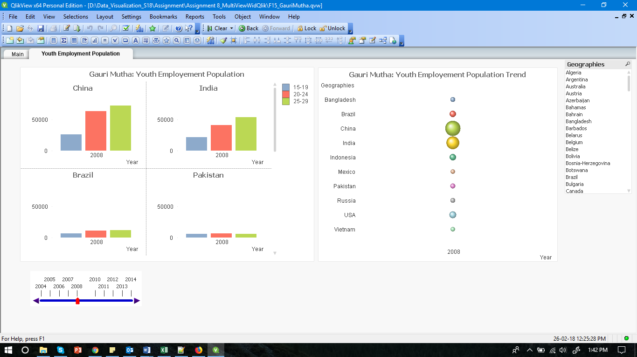

**Note: For all the below questions use the filter functionality provided to properly visualize the data**

* 1. Which is the country having the highest youth employment population between 2004 through 2014? Paste the screen shot of the Youth Employment Population sheet below.

**Answer China**

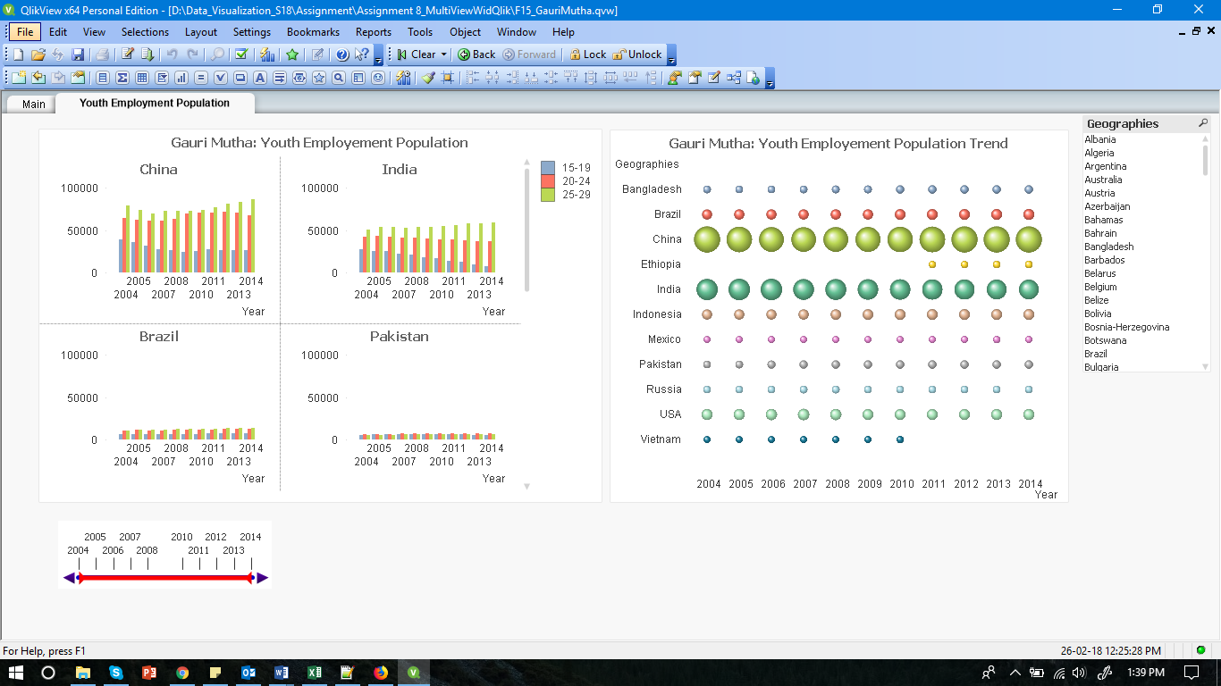

* 1. What is the trend between different age groups (15-19, 20-24, 25-29) do you notice in most of the countries from 2005 to 2014? What does the trend for Pakistan look like between these age groups?

**Answer As per the charts it is seen that for most of the countries, from 2005 to 2014, youth employment is highest for age group 25-29 followed by 20-24 and then follows 15-19. The trend for Pakistan is not the same. In Pakistan employment is highest for age group 20-24 and then 15-19 and then 25-29**

1. **Visualize Youth Gross Income**

**Questions:**

* 1. Paste the screenshot of your sheet

**Answer**

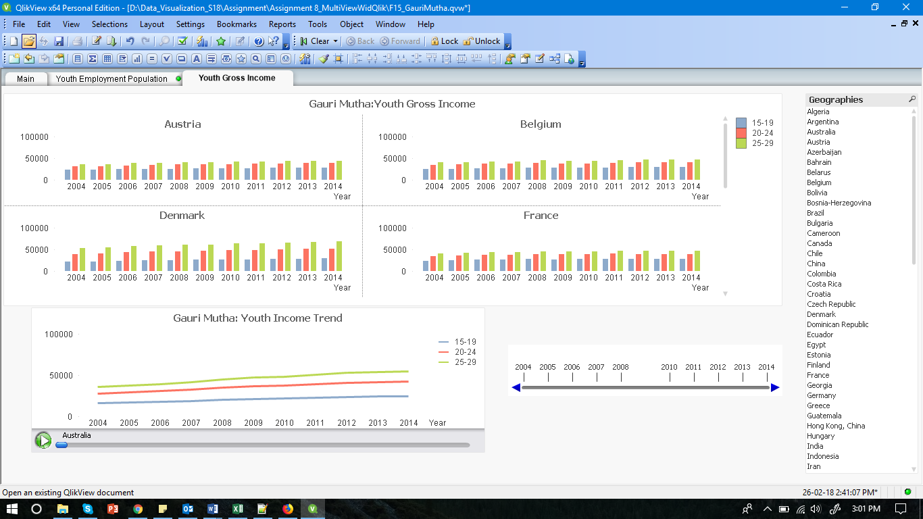

* 1. In which year was there a dip in the youth income in United Arab Emirates across all categories?

**Answer In 2009, there was a dip in the youth income in United Arab Emirates across all categories.**

1. **Visualize Youth Expenditure by Age Category**

**Questions:**

* 1. Paste the screenshot of your sheet

Answer:

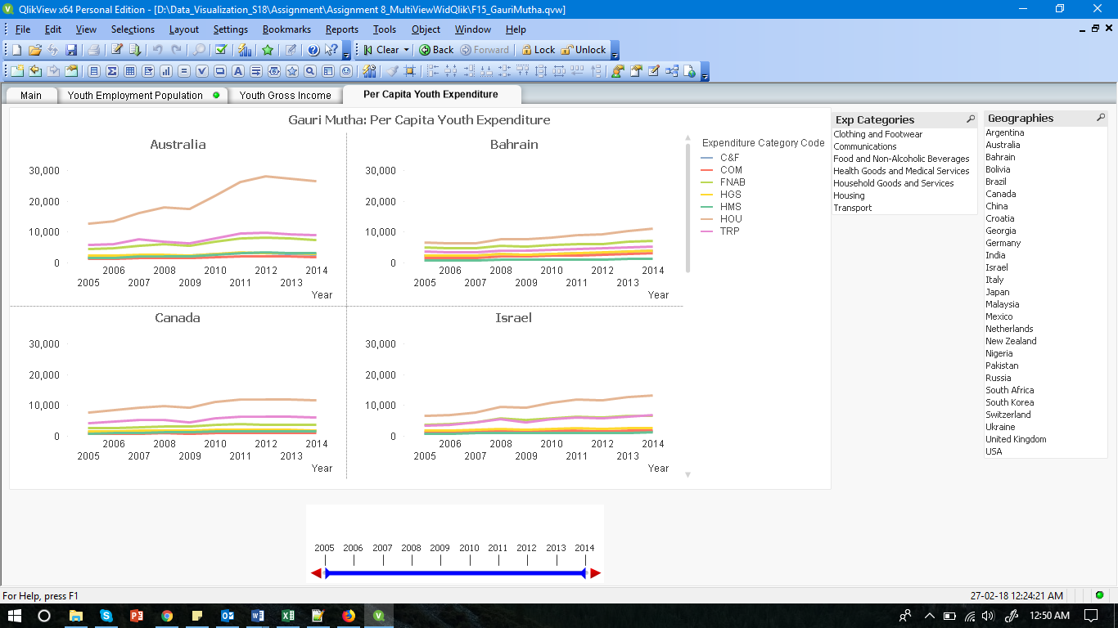

* 1. On Which commodity does the youth spend the most?

Answer: The youth spends most on Housing(HOU).

* 1. On which commodity does the youth in Switzerland spend the most in the year 2007?

Answer: In the year 2007, youth in Switzerland spend most on Housing(HOU)

1. **Visualize Youth Expenditure without Age Categories**

**Questions:**

* 1. Paste the screenshot of your sheet

Answer:

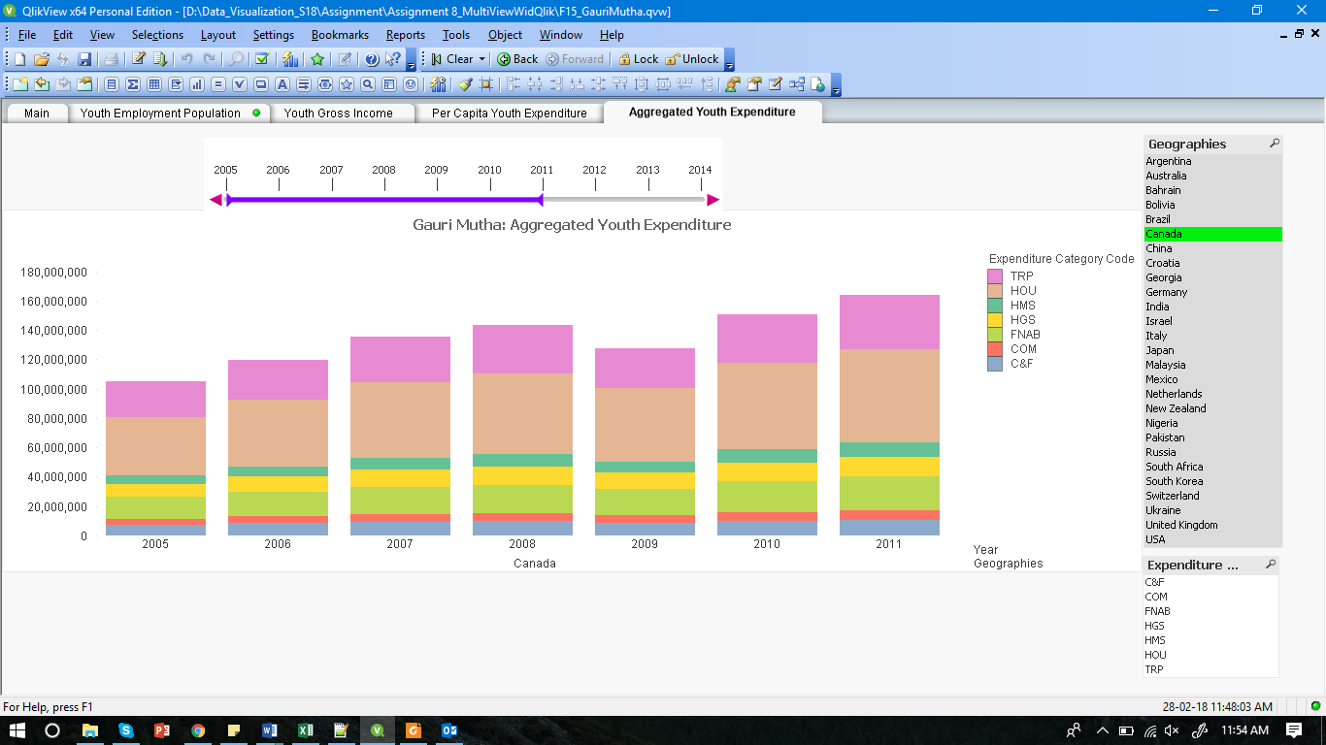

* 1. In which year did the youth spend on housing the most in Switzerland?

Answer: In year 2011, the youth spend the most on housing in Switzerland.

* 1. In which year(s) do you see sudden dip in the youth expenditure in Ukraine?

Answer: In 2009 and 2014, there was a sudden dip in the youth expenditure in Ukraine.